Petrol engine test

On 8th of April 2004 the Hírös Hajó Company and the Yamaha Motor Kft. searched an answer for that frequently asked question, what type of engine should we choose to the K Maxxi 4.60 with a bottom of catamaran which is beloved by anglers because of its stability and the K Maxxi Extra 5.45.
There is also a question what kind of output can be reached at different loading. The test passed off at Kormorán port (www.kormorankikoto.hu) on the Tisza in sunshine, 15 ºC, windy weather.

Can be driven without driving licence
Can be driven with driving test
Loading
four-stroke engine, two-stroke engine
consumption
speed
Petrol engine speed-loading diagram
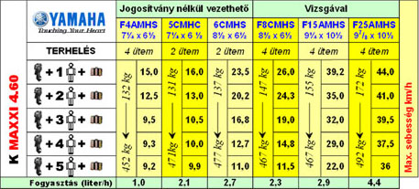
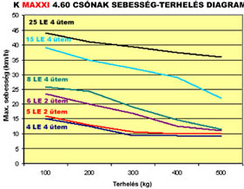
We tested 2 and 4-stroke engines, we used the engines with maximum rev, we measured our maximum speed with the help of a GPS. There is no place here for detailed analysis, further pictures and information can be found at Internet addresses. With the help of the attached tables it can be decided that beside average loading with what type of engine do we reach the desired speed and the most economical operation. To any other question we give you answer with pleasure by phone (see below telephone numbers).

Boat speed-loading diagram

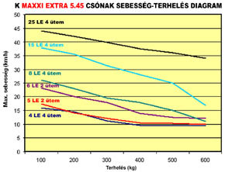
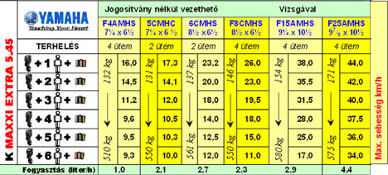
Attention! incontrollable quality reproducitons are in circulation!

Designer and producer of the boats:
Imre JUHAROS
chartered engineer
+36 30/ 9788-120
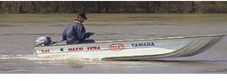
Vendor of motors:
Yamaha Motor Hungária KFT.
1112 Budapest. Budaörsi út 227
+36 1/ 247-1522

